
ATM System Final Report
CSC 834 Software Engineering (Spring 2026)

April 26, 2026
Eastern kentucky University
Linda Rynerson

Table of Contents
I. Introduction 2
A. Problem Statement 4
B. Proposal 4
II. System Description 4
III. System Requirements 4
A. Functional Requirements 4
B. Non-functional Requirements 33
IV. Use Case Diagram 33
V. Class Diagram 34
VI. Sequence Diagrams 35
VII. Activity Diagrams 43
VIII. State Diagrams 52
IX. Database Design 58
A. ER Schema 58
B. Table Schema 58
X. Conclusion 59

Table of Figures
Figure 1: ATM Main Menu 5
Figure 2: Account List 6
Figure 3: Transactions exceeded max limit of $3000 for withdrawal 6
Figure 4: Return to step 1.3 7
Figure 5: Return to step 1.1 7
Figure 6: Withdrawal Amount Entering 8
Figure 7: Customer Enters Amount for Withdrawal 9
Figure 8: Amount entered will exceed max limit for withdrawal. 9
Figure 9: Withdrawal Amount Greater than Balance. 10
Figure 10: Machine does not have enough cash for withdrawal 11
Figure 11: Dispensing the withdrawed cash. 11
Figure 12: Returning to main menu. 12
Figure 13: ATM Main Menu 13
Figure 14:Display account lists to the customer 13
Figure 15: Max Limit reached for the account. 14
Figure 16: Return to step 2.3 15
Figure 17: Return to step 2.1 15
Figure 18:System requests user to enter amount for deposit 16
Figure 19:User enters amount for deposit 16
Figure 20: Amount exceeds max limit. 17
Figure 21: Insert cash into machine. 18
Figure 22:ATM main menu 19
Figure 23: ATM Main Menu 19
Figure 24:Display accounts for check balance. 20
Figure 25:Displaying balance. 21
Figure 26:Return to main menu. 21
Figure 27: ATM Main Menu 22
Figure 28: There is not another account to transfer money into. 22
Figure 29: Accounts to transfer from. 23
Figure 30:Accounts to transfer money to 24
Figure 31: The account has exceeded maximum transaction limit. 25
Figure 32: Return to step 4.4 25
Figure 33: Enter amount for transfer 26
Figure 34:Customer enters amount for transfer 26
Figure 35:Amount will make transactions of the account exceed the max limit 27
Figure 36: The amount to be transferred is greater than the balance of the selected account. 28
Figure 37:Transfer Successful 29
Figure 38:ATM main menu 29
Figure 39: System asks user to tap card. 30
Figure 40:Card is not associated with the bank. 30
Figure 41: User enters pin. 31
Figure 42: Incorrect Pin 32
Figure 43:ATM Main Menu 33
Figure 44: Use Case Diagram for ATM Machine 34
Figure 45: Class Diagram of ATM Machine 35
Figure 46: Sequence Diagram for the Withdraw Money Use Case 37
Figure 47: Sequence Diagram for the Deposit Money Use Case 39
Figure 48: Sequence Diagram for the Check Balance Use Case 39
Figure 49: Sequence Diagram for the Transfer Money Use Case 42
Figure 50: Sequence Diagram for the LogIn Use Case 42
Figure 51: Sequence Diagram for the Logout Use Case 43
Figure 52: Activity Diagram for Withdrawing Money 44
Figure 53: Activity Diagram for the Deposit Money Use Case 46
Figure 54: Activity Diagram for the Check Balance Use Case 48
Figure 55: Activity Diagram for Transfer Money 50
Figure 56: Activity diagram for the login use case 51
Figure 57: Activity Diagram for the Logout Use Case 52
Figure 58: State Diagram for Withdraw Money 53
Figure 59: State Diagram for the Deposit Money Use Case 54
Figure 60: State Diagram for Check Balance Use Case 55
Figure 61: State Diagram for Transfer Money Use Case 56
Figure 62: State Diagram for Login Use Case 57
Figure 63: State Diagram for Logout Use Case 57
Figure 64: ER diagram for ATM machine 58

Introduction

Problem Statement
A new local bank ZZZ needs help to develop a software system for their multiple ATM machines.

Proposal
We propose a software system to integrate the machine to provide services to the customers of ZZZ bank.

System Description
The ATM machines will provide basic operations to the customers of the bank, including depositing money, withdrawing money, checking balances, and transferring money from one account to another. Each machine will be refilled to hold $100,000 cash daily for possible withdrawals. For security reason, each account can have at most $3000 in total for all the transactions (except for checking balance) through ATM machines each day. Effectiveness and efficiency are the primary requirements of the project.

System Requirements

Functional Requirements

- The system shall allow a customer to withdraw money from his/her account.
  - The system shall display a main menu to the customer.
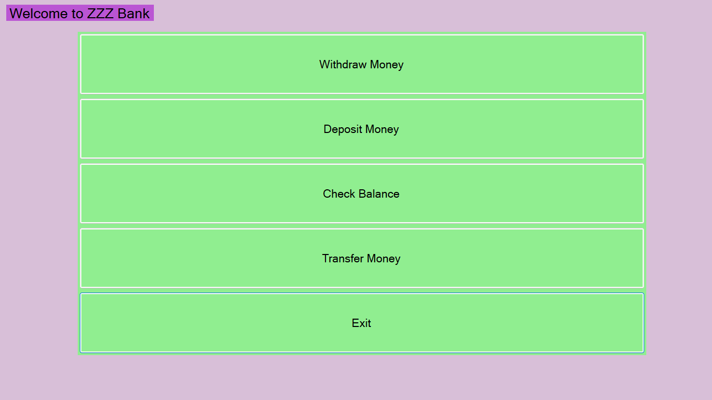
Figure 1: ATM Main Menu
  - The customer shall select “Withdraw Money” button.
  - The system shall display a list of accounts of the customer.
    - The system shall retrieve the account information from the database.
    - The system shall display only the account numbers.
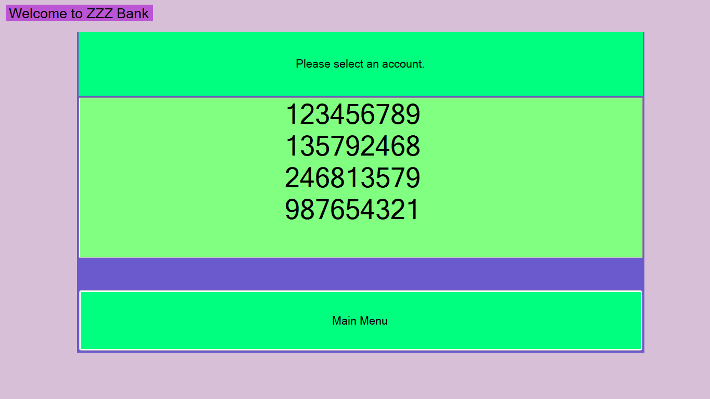
Figure 2: Account List
  - The customer shall select an account number from the list for withdrawal.
  - The system shall update the date of the daily transactions of the selected account.
    - If the last date of the transactions is not today’s date, the system shall change the date of the transactions to today’s date and reset the daily transaction total to $0.
  - The system shall check if the account’s daily transaction total have reached $3000 (see NR1)
    - If the total has reached $3000 already, the system shall display an error message to the customer and check if there is any other account to be selected for withdrawal.
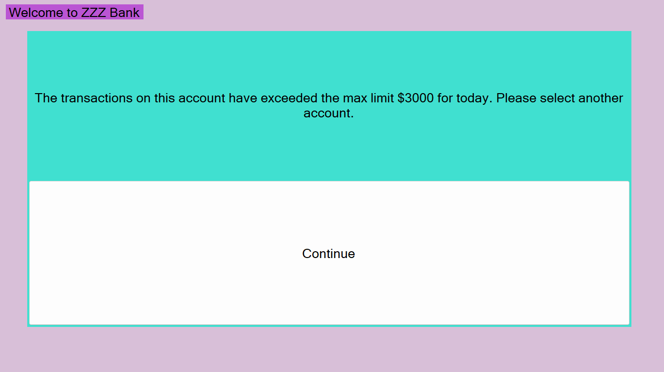
Figure 3: Transactions exceeded max limit of $3000 for withdrawal

      - If there are more accounts to be selected, return to step 1.3.
Figure 4: Return to step 1.3

      - If there are no more accounts to be selected, return to step 1.1.

Figure 5: Return to step 1.1

    - If they have not reached $3000, the system shall continue step 1.6.
  - The system shall request the customer to enter the amount to withdraw.
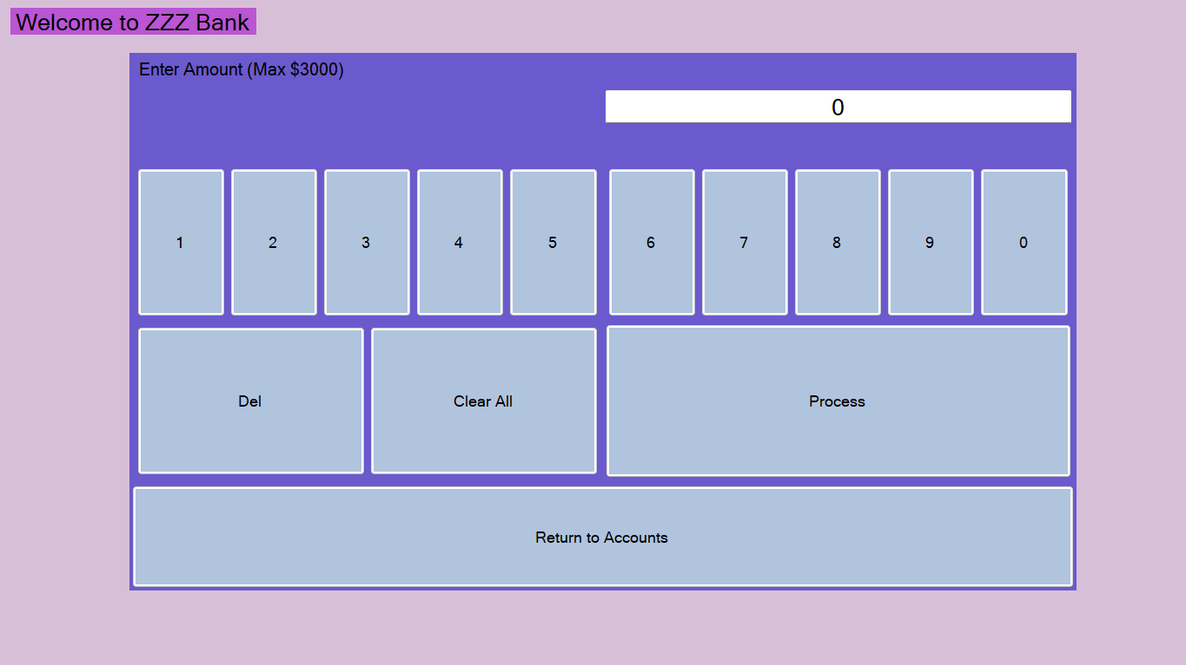
Figure 6: Withdrawal Amount Entering
  - The customer shall enter the amount.
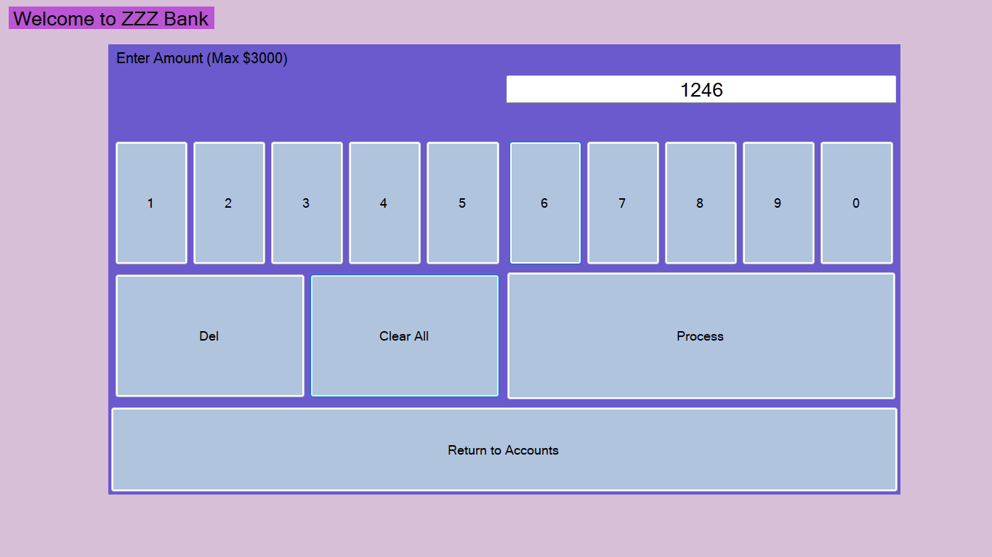
Figure 7: Customer Enters Amount for Withdrawal
  - The system shall check if the total of the amount, plus the daily transaction total is greater than $3000 (see NR1)
    - If the total is greater than $3000, the system shall display an error message to the customer, and return to step 1.5
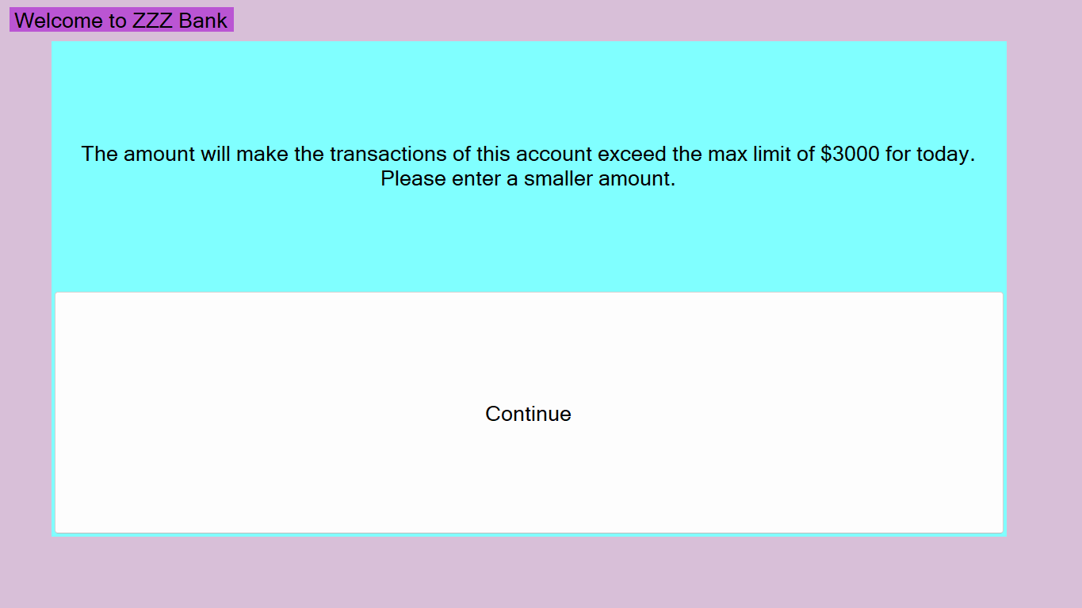
Figure 8: Amount entered will exceed max limit for withdrawal.
    - If the total is less than or equal to $3000, the system shall continue step 1.9.
  - The system shall verify if the amount is less than the current balance of the selected account
    - If the amount is greater than the balance, the system shall display an error message to the customer, and return to step 1.5.
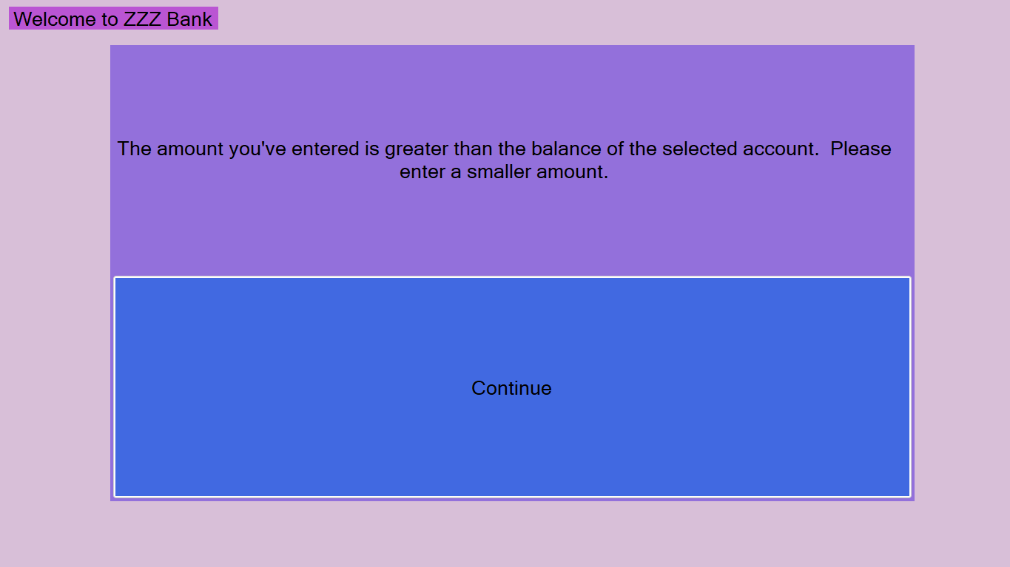
Figure 9: Withdrawal Amount Greater than Balance.

    - If the amount is less than or equal to the current balance, the system shall continue step 1.10
  - The system shall check if the machine has enough cash for the withdrawal.
    - If there is not enough cash for the withdrawal, the system shall display an error message, and return to step 1.6.
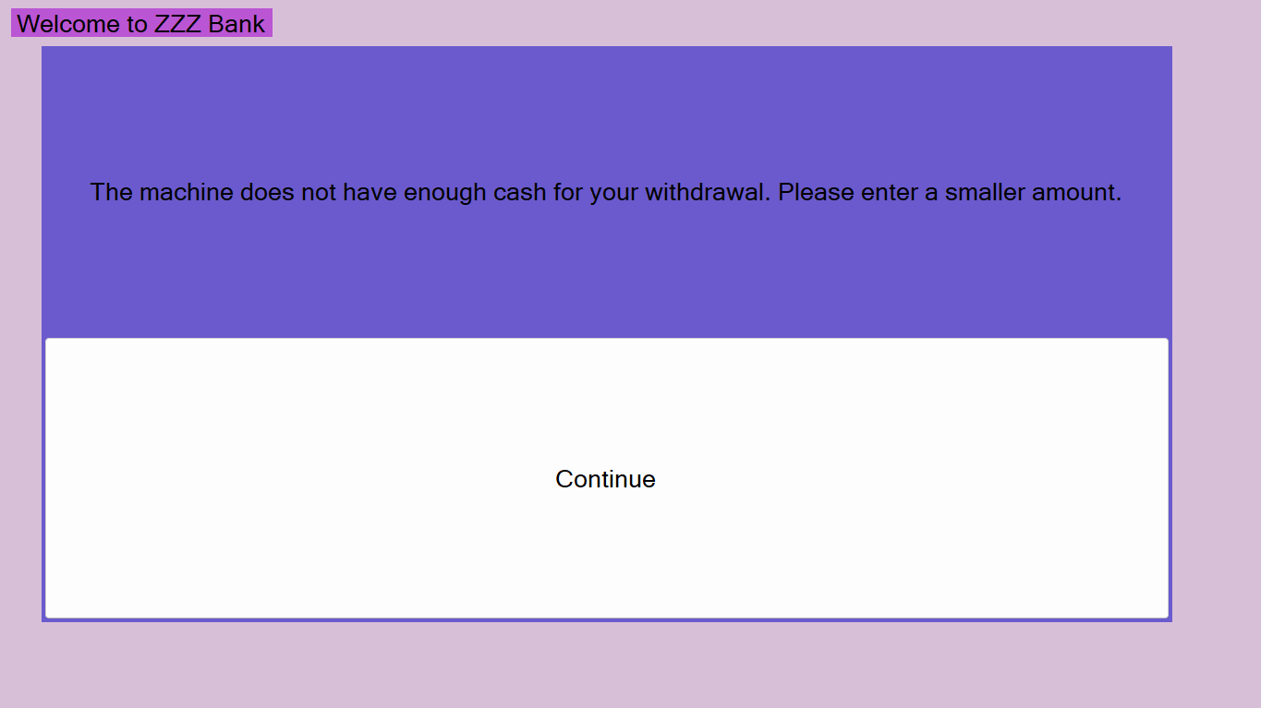
Figure 10: Machine does not have enough cash for withdrawal
    - If there is enough cash for the withdrawal, the system shall continue step 1.11.
  - The system shall dispense the cash.
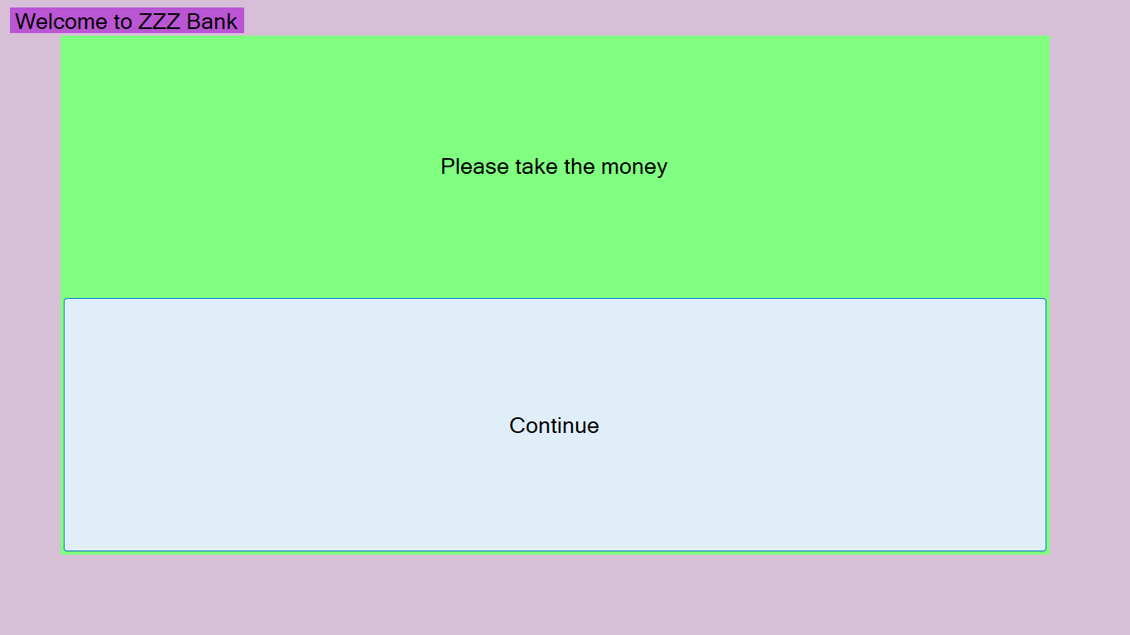
Figure 11: Dispensing the withdrawed cash.
  - The system shall deduct the amount from the balance of the account.
  - The system shall add the amount to the daily transaction total.
  - The system shall store this transaction in the database.
  - The system shall update the account information in the database.
  - The system shall return to the main menu.

Figure 12: Returning to main menu.
- The system shall allow a customer to deposit money to his/her account
  - The system shall display a main menu to the customer.

Figure 13: ATM Main Menu
  - The customer shall select “Deposit Money” button.
  - The system shall display a list of accounts to the customer.

Figure 14:Display account lists to the customer
    - The system shall retrieve the account information from the database.
    - The system shall display only the account numbers.
  - The customer shall select an account number from the list to deposit the money into.
  - The system shall update the date of the daily transactions of the selected account.
    - If the last date of the transactions is not today’s date, the system shall change the date of the transactions to today’s date, and reset the daily transaction total to $0
  - The system shall check if the account’s daily transactions total has reached $3000 (see NR1)
    - If the total has reached $3000 already, the system shall display an error message to the customer, and check if there are any other account to be selected for deposits.

Figure 15: Max Limit reached for the account.
      - If there are more accounts to be selected, return to step 2.3.

Figure 16: Return to step 2.3
      - If there are no more accounts to be selected, return to step 2.1.


Figure 17: Return to step 2.1
    - If they have not reached $3000, the system shall continue step 2.6.
  - The system shall request the customer to enter the amount for deposit.

Figure 18:System requests user to enter amount for deposit
  - The customer shall enter the amount.
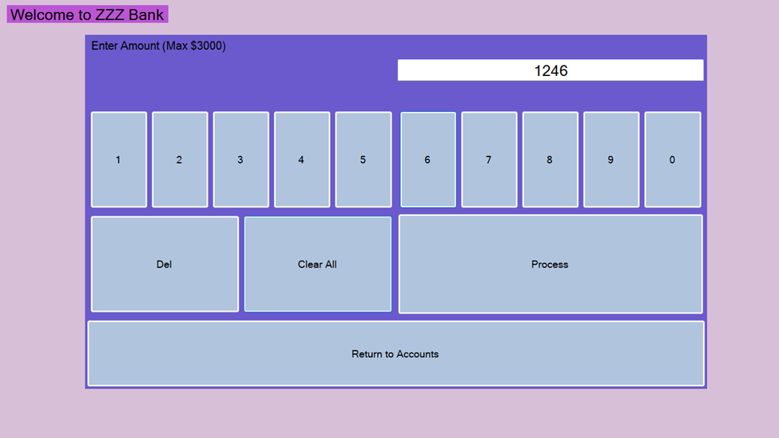
Figure 19:User enters amount for deposit
  - The system shall check if the total of the amount, plus the daily transaction total is greater than $3000 (see NF1).
    - If the total is greater than $3000, the system shall display an error message to the customer, and return to step 2.5.

Figure 20: Amount exceeds max limit.
    - If the total is less than or equal to $3000, the system shall continue step 2.9.
  - The system shall accept the cash.
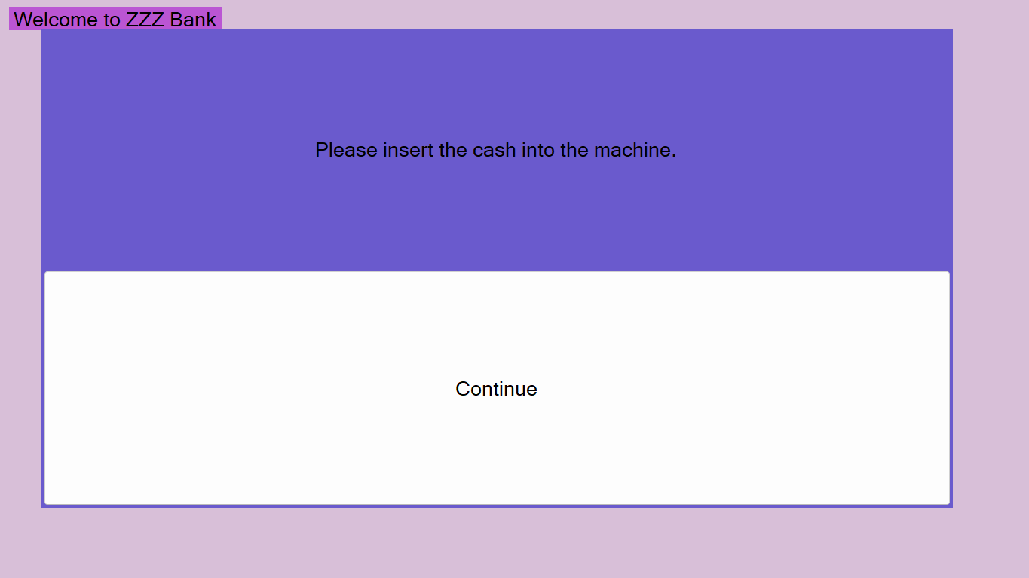
Figure 21: Insert cash into machine.
  - The system shall add the amount to the balance of the account.
  - The system shall add the amount to the daily transaction total.
  - The system shall store this amount in the database.
  - The system shall update the account information in the database.
  - The system shall return to the main menu.

Figure 22:ATM main menu
- The system shall allow a customer to check the balance of his/her account.
  - The system shall display a main menu to the customer.

Figure 23: ATM Main Menu
  - The customer shall select the “Check Balance” button.
  - The system shall display a list of accounts to the customer.
    - The system shall retrieve the account information from the database.
    - The system shall display only the account numbers.

Figure 24:Display accounts for check balance.
  - The customer shall select an account number from the list to check the balance.
  - The system shall update the date of the daily transactions of the selected account.
    - If the last date of the transactions is not today’s date, the system shall change the date of the transactions to today, and reset the daily transaction total to $0.
  - The system shall display the current balance of the account.
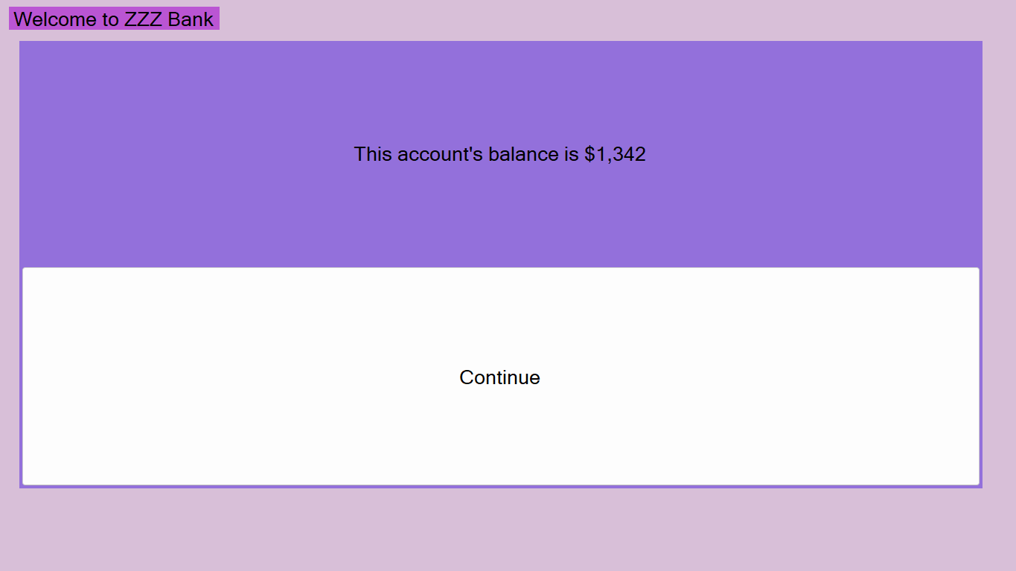
Figure 25:Displaying balance.
  - The system shall update the account information in the database.
  - The system shall return to the main menu.

Figure 26:Return to main menu.
- The system shall allow a customer to transfer money from his/her account to another account that he/she owns.
  - The system shall display a main menu to the customer.

Figure 27: ATM Main Menu
  - The customer shall select the “Transfer Money” button.
  - The system shall check that there are at least two account associated with the customer.
    - If there is only one account associated with the customer, the system shall display an error message and return to step 4.1.
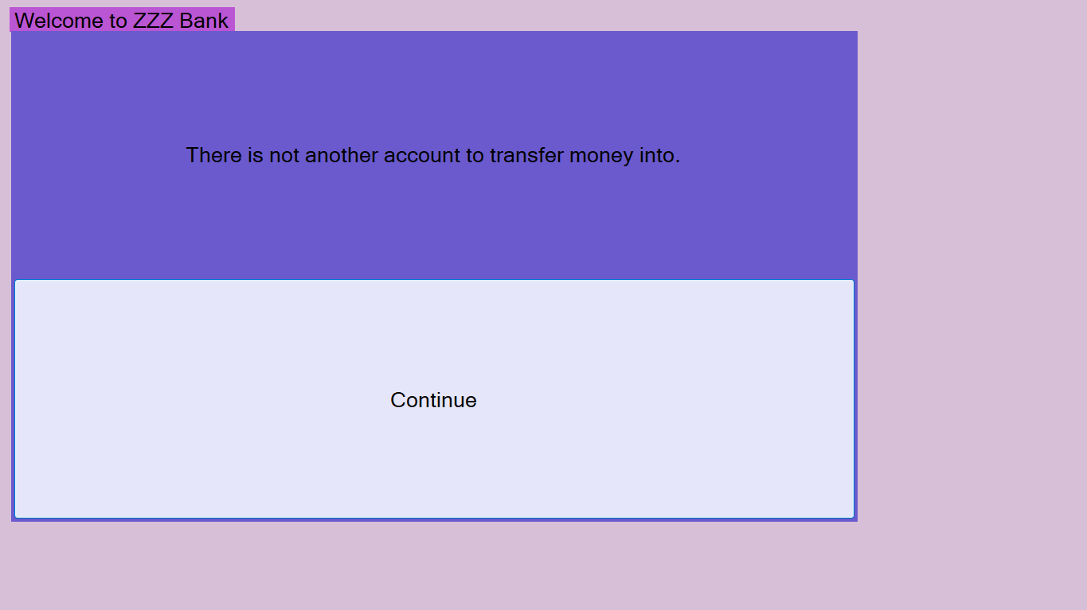
Figure 28: There is not another account to transfer money into.
  - The system shall display a list of accounts to the customer.
    - The system shall retrieve the account information from the database.
    - The system shall display only account numbers.

Figure 29: Accounts to transfer from.
  - The customer shall select an account from the list for transfer.
  - The system shall display a list of accounts for the customer to transfer money to.
    - The system shall retrieve the account information from the database.
    - The system shall display only account numbers.
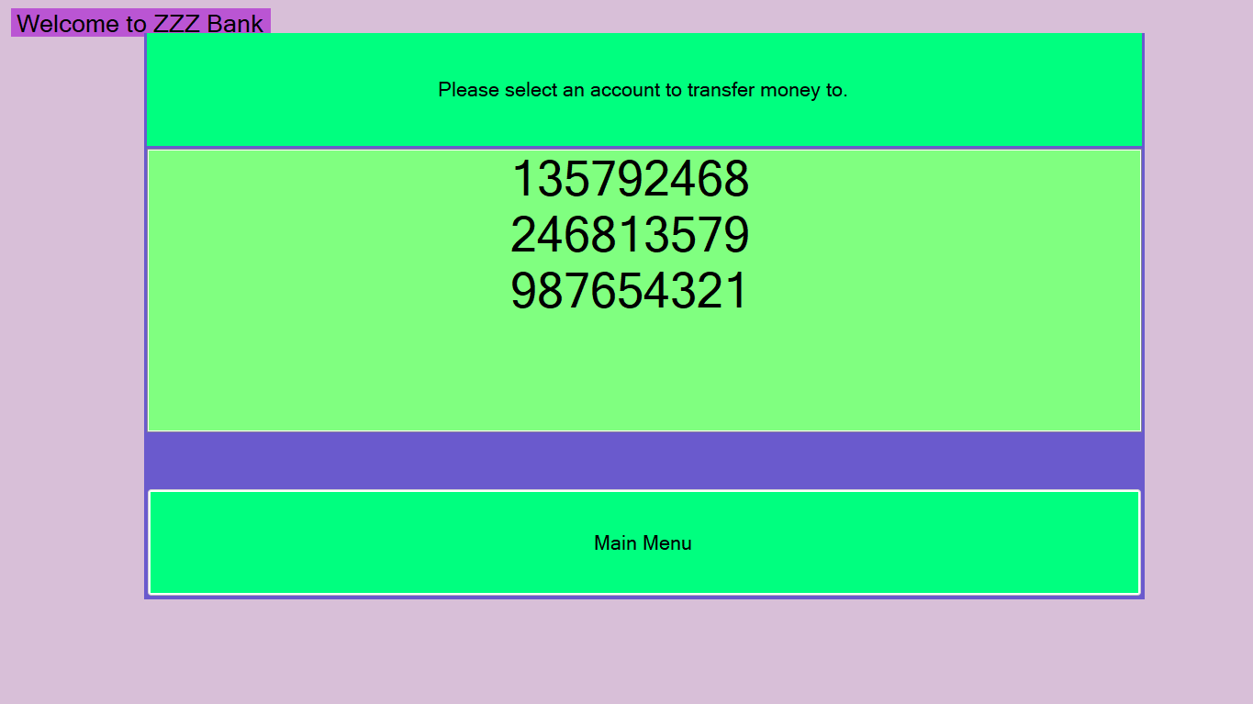
Figure 30:Accounts to transfer money to
  - The customer shall select an account from the list of accounts to transfer money to.
  - The system shall update the date of the daily transactions for the selected account.
    - If the last date of the transactions is not today’s date, the system shall change the date of the transactions to today’s date and reset the daily transaction total to $0.
  - The system shall check if the daily transaction total has reached $3000 (see NR1).
    - If the total has reached $3000 already, the system shall display an error message to the customer and check if there are any other accounts to be selected for transfers.

Figure 31: The account has exceeded maximum transaction limit.
      - If there are more accounts to be selected, return to step 4.4.

Figure 32: Return to step 4.4
      - If there are no accounts to be selected, continue step 4.9.1
    - If the total is less than or equal to $3000, the system shall continue 4.9.
  - The system shall request the customer to enter the amount to transfer to that account.

Figure 33: Enter amount for transfer
  - The customer shall enter the amount.

Figure 34:Customer enters amount for transfer
  - The system shall check if the amount plus the daily transaction total is over $3000. (see NR1).
    - If the total is greater than $3000, the system shall display an error message to the customer, and return to step 4.8.

Figure 35:Amount will make transactions of the account exceed the max limit
    - If the total is less than or equal to $3000, continue step 4.12.
  - The system shall verify that the requested amount is less than or equal to the current balance of the selected account.
    - If there is not enough cash for the transfer, the system shall display an error message, and return to step 4.8.

Figure 36: The amount to be transferred is greater than the balance of the selected account.
    - If the amount is less than or equal to the current balance, the system shall continue step 4.13.
  - The system shall remove the money from the first account.
  - The system shall add the money to the second account.
  - The system shall add the amount to the daily transaction total.
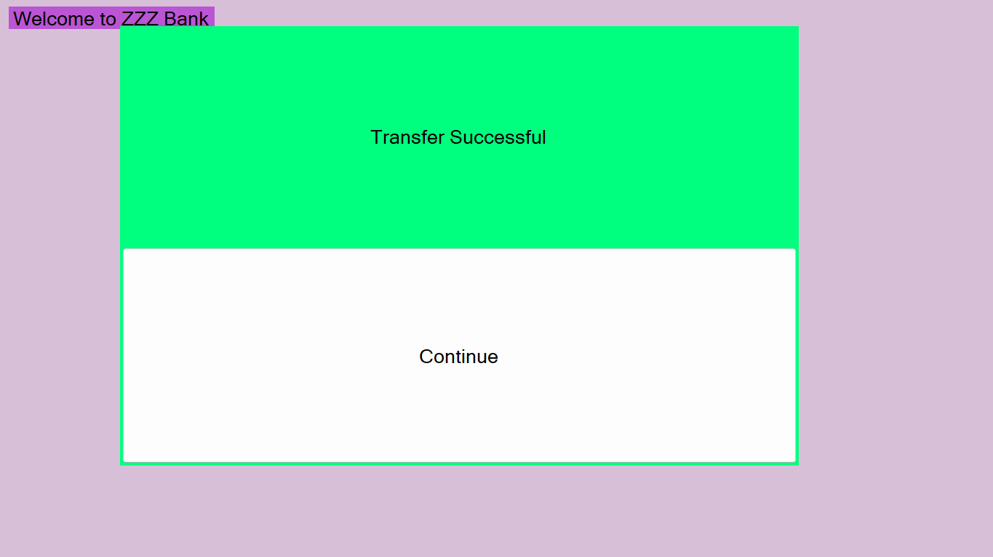
Figure 37:Transfer Successful
  - The system shall store this transaction in the database.
  - The system shall update the account information in the database.
  - The system shall return to the main menu.

Figure 38:ATM main menu

- The system shall allow the user to login with their credentials if they have a bank card.
  - The system shall display a login in screen to the user.
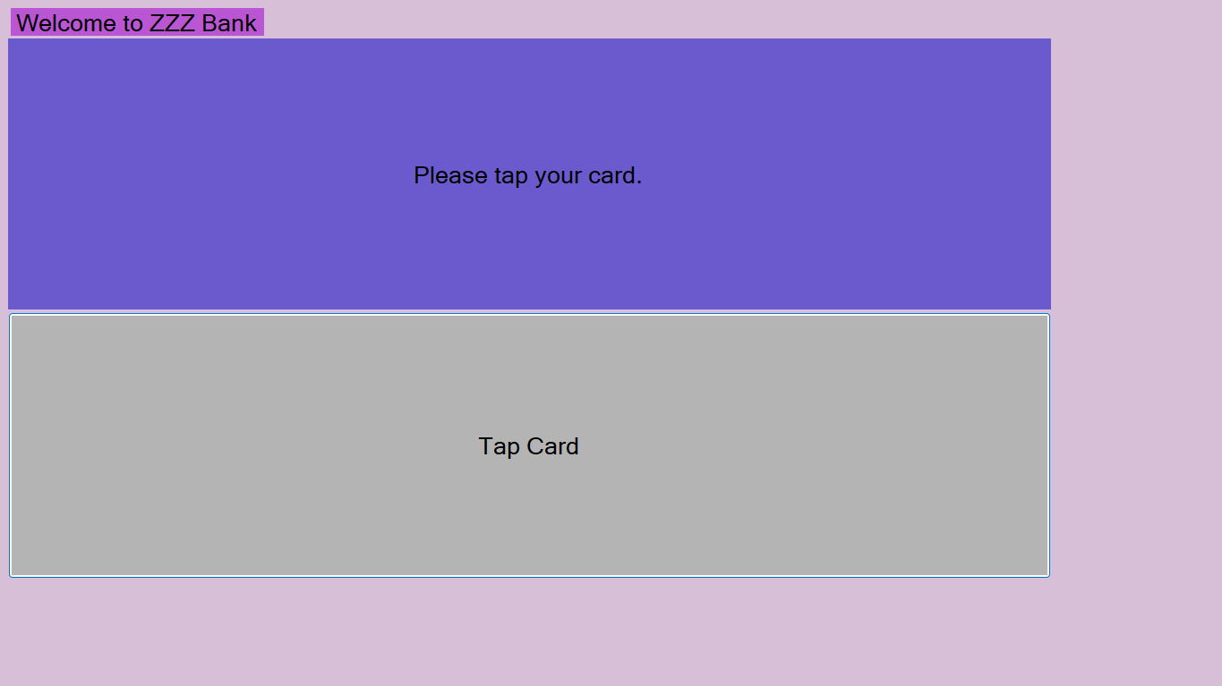
Figure 39: System asks user to tap card.
  - The user shall tap their card on the screen
  - The system shall check if the card is a bank card associated with the bank.
    - If the bank card is not associated with the bank, the system shall display an error message to the user.
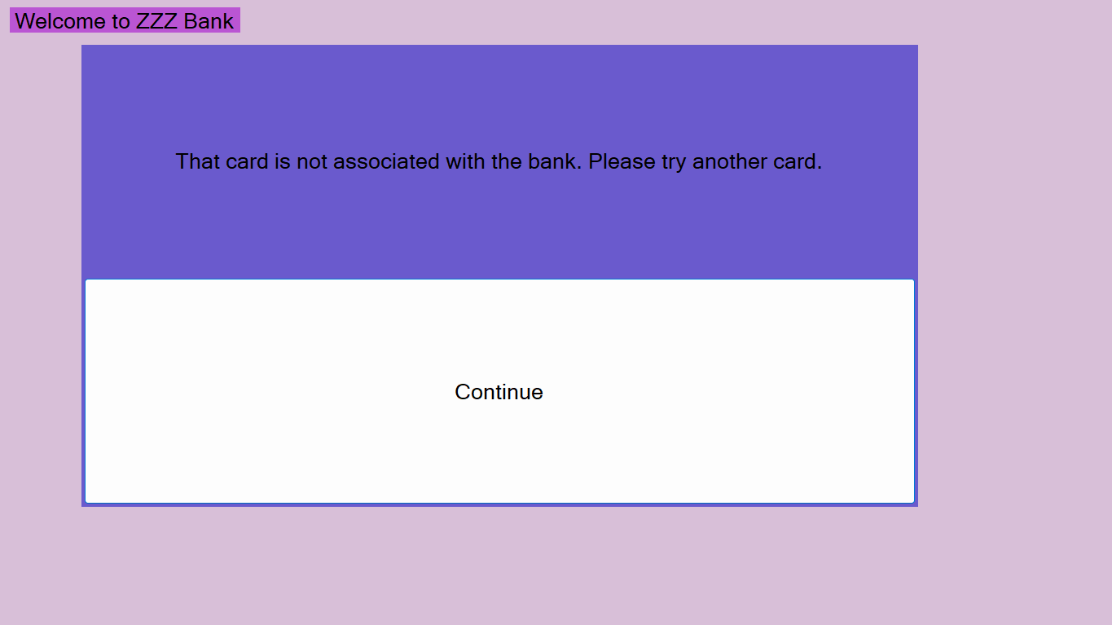
Figure 40:Card is not associated with the bank.
    - If the bank card is associated with the bank, the system shall ask the user for their pin.
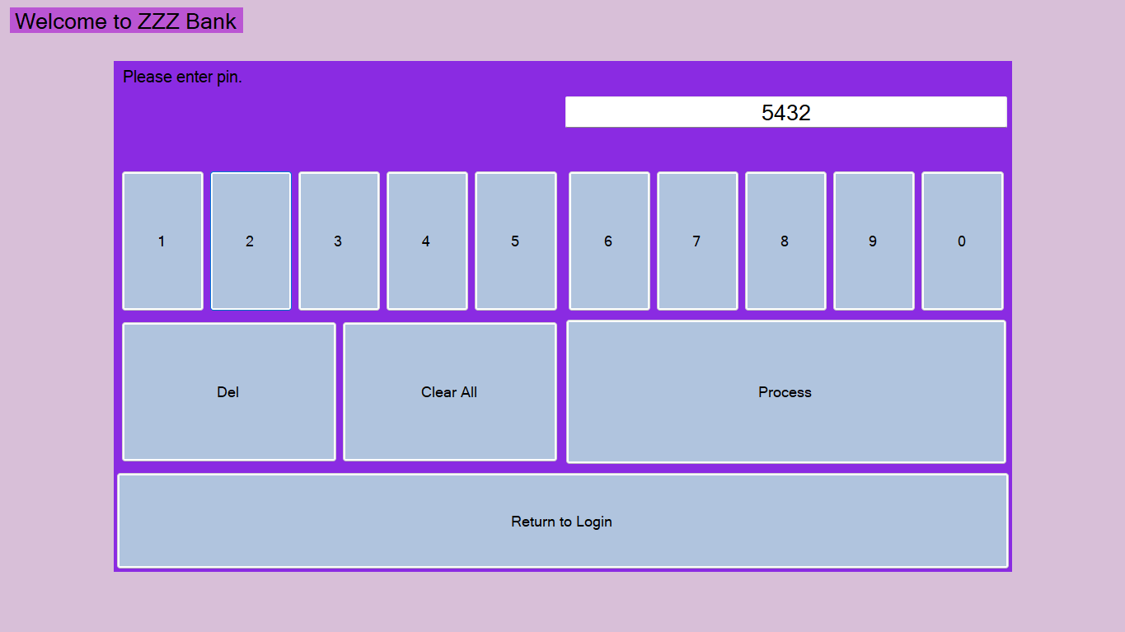
Figure 41: User enters pin.
    - The system shall check if the pin is the correct pin for the account.
      - If the pin is incorrect, the system shall display an error message to the user.
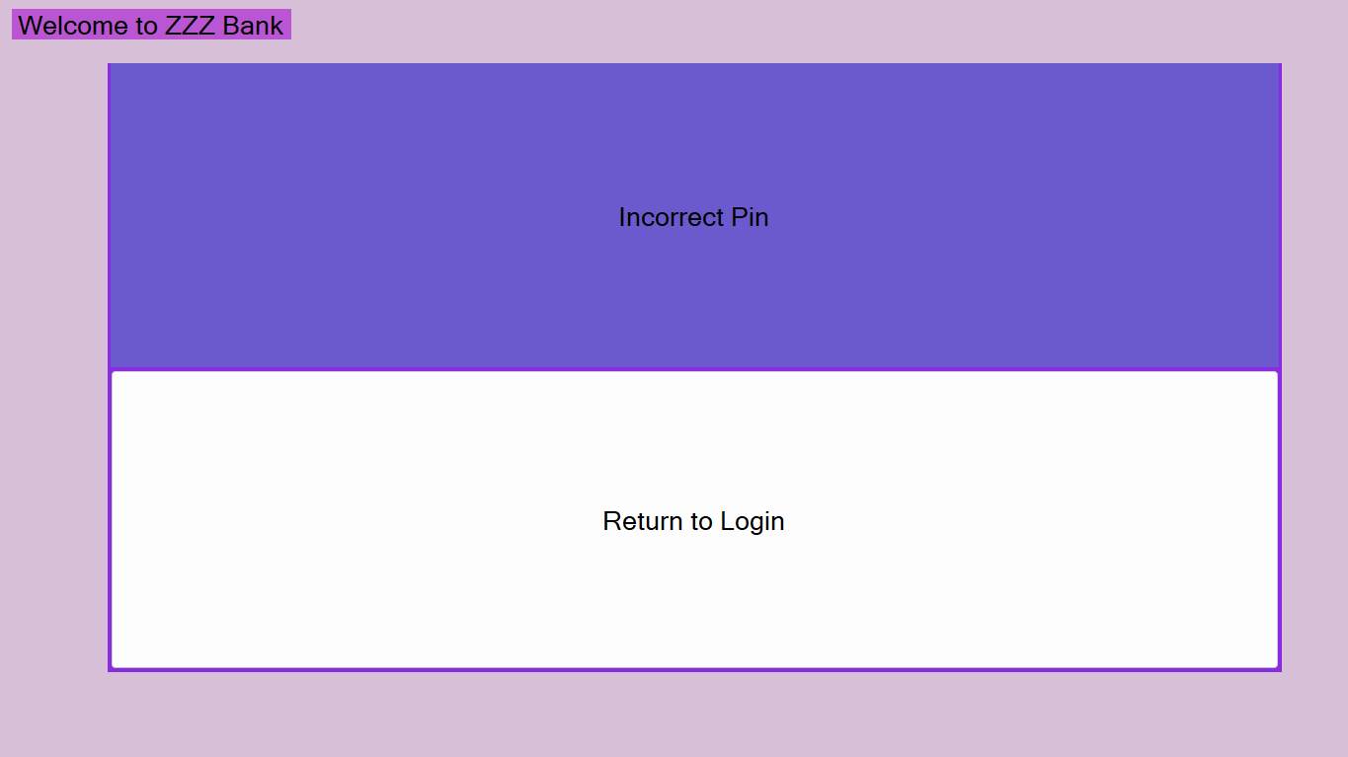
Figure 42: Incorrect Pin
      - If the pin is correct, continue step 5.3.
  - The system shall now login the user and the user is now a customer of the bank.
- The system shall allow the customer to log out of his/her account.
  - The system shall display a main menu to the customer.

Figure 43:ATM Main Menu
  - The customer shall select “Exit”
  - The system shall log the customer out of his/her account and the customer is now a user.

Non-functional Requirements

- The total of daily transactions (withdrawals ad money transfers) shall not exceed $3000 from same account.
- The cash in the machine will be reset to $100000 every day. This action will be done manually by the employees of the bank (The software is not responsible for this part).
- The amount of a deposit will not be added to the balance of an account immediately. The system will show the deposit amount in another way. The action for adding the amount to the balance will be done manually by the employees of the bank (The software system is not responsible for this part.)

Use Case Diagram

Figure 44: Use Case Diagram for ATM Machine
This use-case diagram is to show the services that will be provided to the customers.

Class Diagram
Figure 45: Class Diagram of ATM Machine
This diagram shows the relationships between the different classes in our system and the different attributes/functions each class has.

Sequence Diagrams

Figure 46: Sequence Diagram for the Withdraw Money Use Case
This diagram shows the steps of how the withdraw money use case will be carried out in our code with respect to the time which increases as you go down the page. The diagram shows the different objects that are involved and what functions they will call.
Figure 47: Sequence Diagram for the Deposit Money Use Case
This diagram shows the steps of how the deposit money use case will be carried out in our code with respect to time. It is very similar to the withdraw money use-case, except we are adding money to the machine instead of removing it, and thus we don’t need to check how much money the machine has or that we have enough money to deposit.
Figure 48: Sequence Diagram for the Check Balance Use Case
This is the sequence diagram for our check balance use case. It shows how the check balance requirement will be carried out according to time. It is one of the simpler sequence diagrams, as we don’t need some of the checks that we had in previous use cases, like the max transaction limit.
Figure 49: Sequence Diagram for the Transfer Money Use Case
This diagram shows how the sequence diagram for the transfer money use case will be carried out. It is the most complex operation we have as we are dealing with two Account objects for the transfer. We are essentially doing a withdraw and a deposit together, except the money never reaches the customer’s hands.
Figure 50: Sequence Diagram for the LogIn Use Case
This is our sequence diagram for our LogIn use case. We only have the user actor and the customer class involved in this diagram.
Figure 51: Sequence Diagram for the Logout Use Case
This is the diagram that shows how the logout use case will be carried out in our code. It is the simplest diagram we have. It involves the customer class and the user actor.

Activity Diagrams

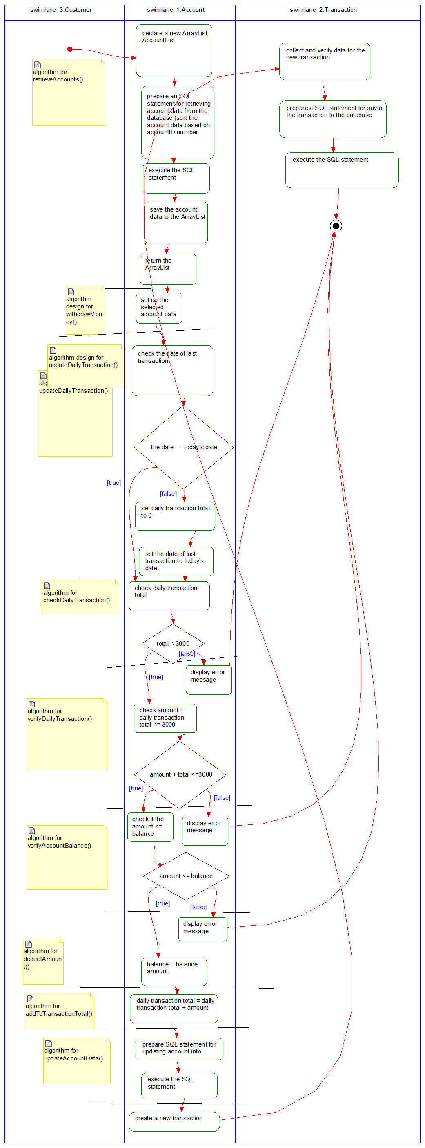
Figure 52: Activity Diagram for Withdrawing Money
This diagram shows the steps of how our withdraw money use case will be carried out. It shows the steps that each of the functions will take to solve the problem.
Figure 53: Activity Diagram for the Deposit Money Use Case
This diagram shows the steps of how our deposit money use case will be carried out. It shows the steps that each of the functions will take to solve the problem.
Figure 54: Activity Diagram for the Check Balance Use Case
This diagram shows the steps of how our check balance use case will be carried out. It shows the steps that each of the functions will take to solve the problem.
Figure 55: Activity Diagram for Transfer Money
This diagram shows how the transfer money operation will be carried out in our code. This is one of the most complex operations as it involves two Account objects.
Figure 56: Activity diagram for the login use case
This shows how the login process will be achieved in the code.
Figure 57: Activity Diagram for the Logout Use Case
This activity diagram shows how the logout use case will be achieved in our code.

State Diagrams
Figure 58: State Diagram for Withdraw Money
This shows the different states and transitions that are present within the Withdraw Money use case.
Figure 59: State Diagram for the Deposit Money Use Case
This diagram shows the different states and transitions present within the Deposit Money Use Case.
Figure 60: State Diagram for Check Balance Use Case
This diagram shows the states and transitions present within the Check Balance Use Case.
Figure 61: State Diagram for Transfer Money Use Case
This is the state diagram for the transfer money use case. It is the most complicated state diagram because you are essentially doing a withdraw on one account and doing a deposit on another. You also must retrieve the information for both accounts.
Figure 62: State Diagram for Login Use Case
This is the state diagram for the Login use case. The state diagram shows the different states and transitions for this use case.
Figure 63: State Diagram for Logout Use Case
This is the state diagram for the logout use case. It is the simplest state diagram we have with only two states and one transition.

Database Design

ER Schema
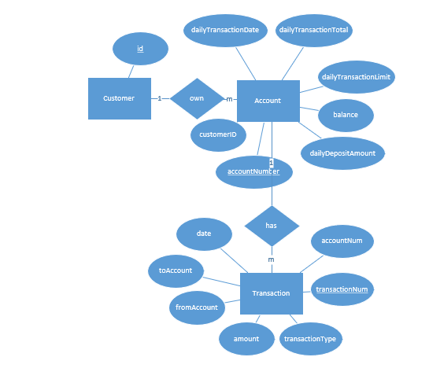
Figure 64: ER diagram for ATM machine
This is the diagram that shows how our databases will interact with each other and the attributes that they will have. The databases are based off our class diagram.

Table Schema

Customer
id

Account
accountNumber | customerID | dailyTransactionDate | dailyTransactionTotal | balance | dailyDepositAmount

Transaction
transactionNum | accountNum | transactionType | amount | date | fromAccount | toAccount

These are the tables we will create for our project. There are three tables: Customer, Account, and Transaction. The Customer table uses id as its primary key, which gets passed to Account as CustomerID. Account uses accountNumber as its primary key, which then gets passed two accountNum in the transaction table. Transaction uses transaction number as its primary key.

Conclusion
I successfully developed a working system for the client according to the client’s specifications. The entire project was completed using the waterfall method which consists of analysis, design, coding, testing, and maintenance steps. I started the analysis phase by developing the requirements specification, use-case diagram, and domain diagrams. I then moved to the design phase with the activity, sequence, and state diagrams. I continued with the design phase with the development of the ER diagram and schemas for the system. I implemented the schemas and developed the code for the system during the coding phase. A few improvements could be made to the system I developed. The login screen could be more secure by using hashes to encrypt the password the user enters and the one the system expects. The digits could also appear as *s on the screen instead of the pin number. The login screen could also contain more cards for the user to choose from. The transfer money feature could be made more secure by stopping the transaction early and displaying an error message to the user if either the removal of money from the first account or the addition of money to the other account fails. Another improvement I thought of was turning the system into an embedded system. Another way you could possibly improve the system is by using a machine learning algorithm to search for irregularities in the transactions data and alert the customer of any suspicious transactions. These are some of the ways the system could be improved in the future.

